# **Data Preparation**

In task 1, I went through the dataset column by column looking for errors. First, I did a quick manual inspection of the dataset, mainly keeping an eye out on missing values or NaN or if there are incorrect data types ie an int rather than a string. Then, I proceeded to use python to check for data type inconsistencies, missing values, impossible values and other errors as outlined in detail below.

## Error 1 – Incorrect data type (Player, Pos, Tm)

The initial errors located is that pandas dataframe sees ‘Player’, ‘Pos’ and ‘Tm’ columns as an object data type. I have corrected this by using ‘pandas.DataFrame.astype’ to manually set those columns as string data. This allows for usage of string methods in python later. However, this also notified me to errors in Pos and Tm columns as spaces or type mismatch can result in the data being classified as an object.

## Error 2 – Redundant white space & others (Pos)

Some data entries in the Position column contained redundant white space, extra letters / symbols on the values or values were not capitalised. To fix this, I have used ‘.str.lstrip()’ and ‘.str.rstrip()’ to remove redundant white space, removed extra letters and symbols from the data entries then capitalised any values that were in lower case.

## Error 3 – Impossible values (Age)

When checking for minimum and maximum ages of the players, it showed a minimum of -19 then a maximum of 280. A more though search into the data showed that these are the only two impossible values for the Age column. I proceeded to replace them with 19 and 28 respectively as they appear to be typos and not false information.

## Error 4 – Redundant white space & others (Team)

Same actions have been taken on the Teams column to remove redundant white space & capitalisation. But, this time, the Team name had an instance of ‘H0U’ rather than ‘HOU’ which is corrected.

## Error 5 – Null values (FG%)

When using ‘.isnull().values.any()’, a true value was returned indicating there are null values in FG%. Null values has been filled with 0.

## Error 6 – Null values (3P%)

Same checks and fixing steps taken as the FG% column.

## Error 7 – Null values (2P%)

Same checks and fixing steps taken as the FG% and 3P% column.

## Error 8 – Null values (FT%)

Same checks and fixing steps taken as the FG%, 3P% and 2P% column.

## Error 9 – Incorrect values (PTS)

Two players’ PTS values were over 2000. I fixed this by recalculating their PTS scores then overwriting their incorrect scores with the recalculated values.

## Error 10 – Duplicate Player Data

At the start, we noticed a 10 players who has played for different teams resulting in duplicate entries for them. To fix these values, I added up all the different values such as their scores / points. These are then overwritten onto their last entry, so that their team and position values would base off their current team. All other replicate entries are then deleted.

## Unmentioned values

Any columns I did not mention here means that I did not find any problems with them, but validation checks are in the Jupyter notebook.

## Data checking section

This section performs a few basic checks to ensure no errors remain in the dataset. These tests include checking for whether the lower and upper bounds of the data meet the requirements or expected values. Such as no ages below 18, number of teams and ‘PTS’ limit ect. Checks on data type for each column is also performed to ensure the actual data type matches what we expect the datatype to be. Finally, another check for NaN values are performed on each column to ensure nothing was missed during data cleaning.

# **Data Exploration**

## Task 2.1

“My answer to Task 2.1”

## Task 2.2

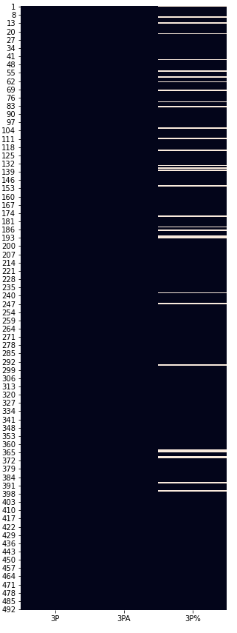In this task, I first re-imported the original dataset containing errors, then use ‘.head()’ to check that this had worked as expected. Then using ‘.info()’, we can see quite a few entries are missing since we expect to see 512 non-null whereas it shows there are only 479 non-null. Using a temporary dataframe, I located the players with missing values in their 3P% column and listed out their names.

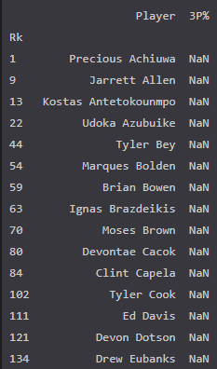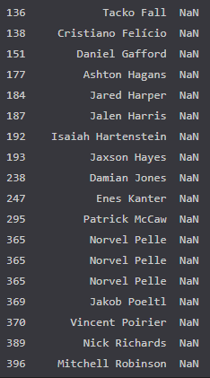

I also used a heatmap to visualise the rough number and location of these errors using a heatmap. (above right). There were a total of 33 errors in the entries if we count repeated players.

## Task 2.3

“My answer to Task 2.3”

**References**

* [1]"seaborn heatmap - Python Tutorial", Pythonbasics.org, 2021. [Online]. Available: https://pythonbasics.org/seaborn-heatmap/. [Accessed: 09- Apr- 2021].
* [2]"How to change a Seaborn plot size?", Dataforeverybody.com, 2021. [Online]. Available: https://www.dataforeverybody.com/seaborn-plot-figure-size/. [Accessed: 17- Apr- 2021].
* [3]"How To Annotate Bars in Barplot with Matplotlib in Python? - GeeksforGeeks", GeeksforGeeks, 2021. [Online]. Available: https://www.geeksforgeeks.org/how-to-annotate-bars-in-barplot-with-matplotlib-in-python/. [Accessed: 17- Apr- 2021].
* [4]2021. [Online]. Available: https://muddoo.com/tag/how-to-add-percentage-values-to-pie-chart-in-python/. [Accessed: 17- Apr- 2021].